Choice Price AB test result Update as of 2017-09-12 01:30 AM:

As of this Morning, 26 days into the test, the Test Group outperformed the Control Group in Revenue per Visitor,

1. Neither the ATS nor the Conversion is significantly different at this moment
2. The conversion rate of the Test Group is -4% lower than that of the Control Group
3. The ATS of the Test Group is +6% Higher than that of the Control Group
4. All in all, the Test Group is giving us a +2% lift in Revenue per Visitor over the control Group

You can find the report here, <https://data.points.com/#/views/ChoicePriceTestAug_17/Summary?:iid=1>

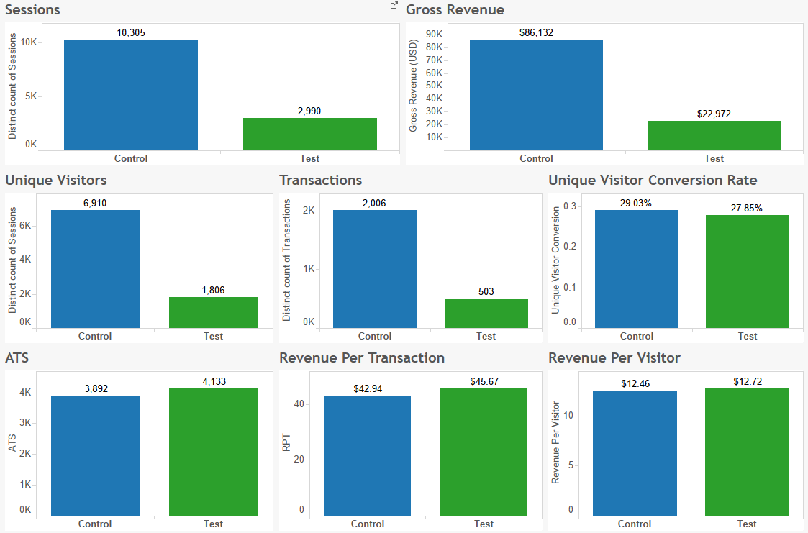

Performance Post Promotion (September 6th – September 12th 1:30 AM)

1. The conversion rate of the Test Group is -12% lower than that of the Control Group
2. The ATS of the Test Group is -7% Lower than that of the Control Group
3. All in all, the Test Group is -17% Lower in Revenue per Visitor compared to the control Group

We are seeing downwards performance in the Test Group post promo on almost all metrics, Matt and I will have a dive into the data and share some insights after our meeting.